**Deep Learning Project**

**Object Detection for Drones**

By Siddhartha Reddy Lingala Bayanna

# **PHASE 1**

## Problem Statement

### Need for the project

Modern drones are equipped with cameras and are very prospective for a variety of commercial uses such as aerial photography, surveillance, etc. In order to massively deploy drones and further reduce their costs, it’s necessary to power drones with smart computer vision and autopilot. In the application of aerial photography, object detection and tracking are essential to capturing key objects in a scene. There are significant challenges with drones due to top-down view angles and real-time constraints. Additionally, The strong weight and area constraint of embedded hardware that limits the drones to run computation intensive algorithms, such as deep learning, with limited hardware resource

### Existing Models

Generally, we use Object Detection Models like YOLO, SSD Mobilenet & RetinaNet to detect objects.

When we Directly apply previous models to tackle object detection task on drone-captured scenarios we majorly face three problems.

1. First, the object scale varies violently because the flight altitude of drones change greatly.
2. Second, drone-captured images contain objects with high density, which brings in blockage between objects.
3. Third, drone-captured images always contain confusing geographic elements because of covering large area. These problems make the object detection of drone-captured images very challenging.

### Our Solution

We will train the existing Models using object-detection datasets (VisDrone-2019 Dataset) that are specific to drones so that we can improve the accuracy of these models.

## Steps & Workflow:

1. Change the actual annotations of Vis Drone dataset to Yolov5 label format.
2. Load existing weights YOLOv5 and fine Tune them.
3. Train model on the VisDrone-2019 dataset.
4. Evaluate performance of all models on actual drone footage
5. Compare the models (**YOLOV5,TPH-YOLOV5**,SSD,RETINANET) in terms of accuracy, speed and memory.

## About the Dataset

VisDrone is a large-scale benchmark with carefully annotated ground-truth for various important computer vision tasks, to make vision meet drones. The VisDrone2019 dataset is collected by the AISKYEYE team at Lab of Machine Learning and Data Mining, Tianjin University, China. The benchmark dataset consists of 288 video clips formed by 261,908 frames and 10,209 static images, captured by various drone-mounted cameras, covering a wide range of aspects including location (taken from 14 different cities separated by thousands of kilometers in China), environment (urban and country), objects (pedestrian, vehicles, bicycles, etc.), and density (sparse and crowded scenes). Note that, the dataset was collected using various drone platforms (i.e., drones with different models), in different scenarios, and under various weather and lighting conditions. These frames are manually annotated with more than 2.6 million bounding boxes of targets of frequent interests, such as pedestrians, cars, bicycles, and tricycles. Some important attributes including scene visibility, object class and occlusion, are also provided for better data utilization.

### Annotation Format

bbox_left, bbox_top, bbox_width, bbox_height, score, object_category, truncation, occlusion

**bbox_left**

The x coordinate of the top-left corner of the predicted bounding box

**bbox_top**

The y coordinate of the top-left corner of the predicted object bounding box

**bbox_width**

The width in pixels of the predicted object bounding box

**bbox_height**

The height in pixels of the predicted object bounding box

**Score**

the score in the DETECTION file indicates the confidence of the predicted bounding box enclosing an object instance.

The score in GROUNDTRUTH file is set to 1 or 0.

* 1 indicates the bounding box is considered in evaluation.
* 0 indicates the bounding box will be ignored.

**Object Category**

The object category indicates the type of annotated object:

* ignored regions(0)
* pedestrian(1)
* people(2)
* bicycle(3)
* car(4)
* van(5)
* truck(6)
* tricycle(7)
* awning-tricycle(8)
* bus(9)
* motor(10)
* others(11)

**Truncation**

The score in the DETECTION result file should be set to the constant -1.

The score in the GROUNDTRUTH file indicates the degree of object parts appears outside a frame:

* no truncation = 0 (truncation ratio 0%)
* partial truncation = 1 (truncation ratio 1% ~ 50%)

**Occlusion**

The score in the DETECTION file should be set to the constant -1.

The score in the GROUNDTRUTH file indicates the fraction of objects being occluded

* no occlusion = 0 (occlusion ratio 0%)
* partial occlusion = 1 (occlusion ratio 1% ~ 50%)
* occlusion = 2 (occlusion ratio 50% ~ 100%)

## Exploratory Analysis

* Ten object categories:

pedestrian, person, car, van, bus, truck, motor, bicycle, awning tricycle, and tricycle

* Images are manually annotated with more than 2.6 million bounding boxes of targets of frequent interest.
* 288 video clips formed by 261,908 frames and 10,209 static images, captured by various drone-mounted cameras

## Sample 1st Image:

**Annotations for 1st image:**

684,8,273,116,0,0,0,0

406,119,265,70,0,0,0,0

255,22,119,128,0,0,0,0

1,3,209,78,0,0,0,0

708,471,74,33,1,4,0,1

1st Image:

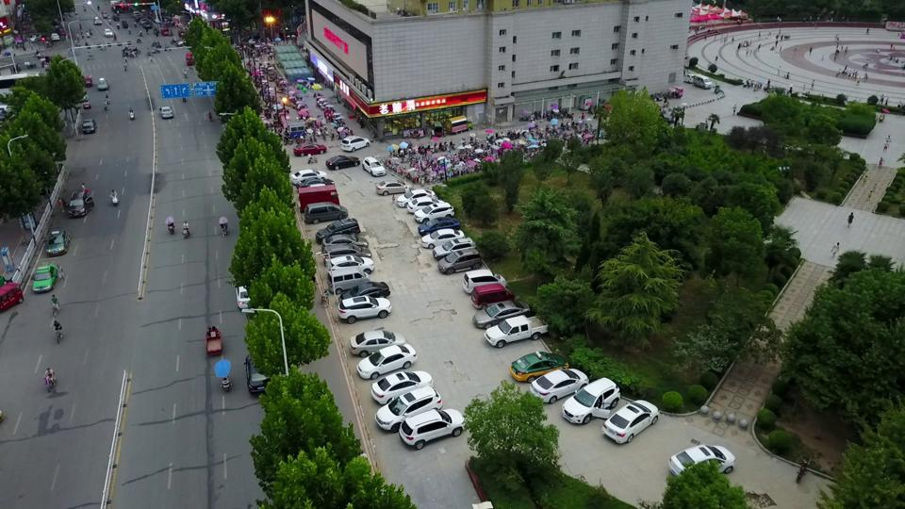

1st Image with some annotations plotted

## Pre-processing

1. Firstly, we need to convert the annotations from the custom format to the standard PASCAL VOC format.
2. For YOLO model, we convert PASCAL VOC to YOLO annotation format.

This prepares our dataset for training the three models.

Refer to pre-processing python notebook for detailed code,

## Objectives

1. Improve the accuracy of all models by training on drone specific dataset.
2. Compare accuracy of all the models.
3. Compare speed of the models.
4. Compare memory footprint of all the models.

## Evaluation Metrics

The performance of algorithms is evaluated by the average precision (AP) across different object categories and intersection over union (IoU) thresholds. Specifically, AP is computed by averaging over all 10 IoU thresholds, i.e., in the range [0.50 : 0.95] with uniform step size 0.05 of all categories.

**IoU**

Intersection over Union (IoU) is used when calculating mAP. It is a number from 0 to 1 that specifies the amount of overlap between the predicted and ground truth bounding box.

* an IoU of 0 means that there is no overlap between the boxes
* an IoU of 1 means that the union of the boxes is the same as their overlap indicating that they are completely overlapping

IoU is an important accuracy measure to track when gathering human annotations. The industry best practice is to include a minimum IoU requirement for their human annotation tasks, to ensure that the annotations that are delivered have an IoU >= X (where X = 0.95 is typical) with respect to the “perfect” annotation of that object, as determined by the annotation schema for the project (i.e. box vehicles as tight as possible, including all visible parts of them, including the wheels). State of the are detectors, on the other hand, typically do not perform at a 0.95 IoU

**mAP in short**

Mean average precision (mAP) is calculated by first gathering a set of predicted object detections and a set of ground truth object annotations.

* For each prediction, IoU is computed with respect to each ground truth box in the image.
* These IoUs are then thresholded to some value (generally between 0.5 and 0.95) and predictions are matched with ground truth boxes using a greedy strategy (i.e. highest IoUs are matched first).
* A precision-recall (PR) curve is then generated for each object class and the average precision (AP) is computed. A PR curve takes into account the performance of a model with respect to true positives, false positives, and false negatives over a range of confidence values.
* The mean of the AP of all object classes is the mAP.
* When evaluating the COCO dataset, this is repeated with 10 IoU thresholds from 0.5 to 0.95 and averaged.

# **PHASE 2.1**

## Literature Review

|  |  |  |  |  |  |
| --- | --- | --- | --- | --- | --- |
| **S.No.** | **Author** | **Type of Paper** | **Title & Link** | **Models** | **Pros & Cons** |
| 1 | Subrahmanyam Vaddi | Thesis | [Efficient Object Detection](https://arxiv.org/pdf/1906.00786) | RCNN | **Pros:** First detector which proposed the two step detection approach.  **Cons:** has a complex multi-step training pipeline which requires careful tweaking of parameters  quite ineﬃcient as it has overhead of running every region proposal through the convolutional base. |
|  |  |  |  | Fast RCNN | **Pros**: ROI algorithm reduces overhead by running the convolutional base just once over the entire image to generate a feature map. It crops the regions from this generated feature map instead of the entire input image thus reducing both the time and space.  Fast RCNN is more speed and memory eﬃcient compared to RCNN  introduces a simpler single step training pipeline and a new loss function  **Cons**: it still suﬀers with an overhead of region proposal step done by selective search algorithm, taking lot of time to generate proposals |
|  |  |  |  | Faster RCNN | **Pros**: Faster RCNN introduced the Region Proposal Network (RPN) to replace Selective Search, which have the capability of predicting regions of multiple scales and aspect ratios across the image using concept called anchors  **Cons**: Scale invariance was one of the problems not dealt by Faster RCNN. The model should be able to detect the object up close and also from far way |
|  |  |  |  | FPN | **Pros**: FPN model solves the problem Of scale invariance by creating multiple feature maps that are designed to represent the image at diﬀerent scales. This is done using lateral scales. |
|  |  |  |  | RetinaNet | **Pros**: RetinaNet employs a Feature Pyramid Network (FPN) built on top of ResNet as backbone.  RetinaNet solved the problem of class imbalance with their novel loss function and boasts the state of the art results in accuracy and speed compared to all other detectors.  **Cons**: Even though RetinaNet performed well on ImageNet dataset, it had major drawbacks in performance on aerial image dataset because of presence of very small scaled objects in aerial images. |
|  |  |  |  | DFPN | **Pros**: To avoid class imbalance, it used a dynamic loss function, which down weights the loss contributed by easily classiﬁed examples.  This loss function can automatically down weight the contribution of easy examples during training and rapidly focus the model on hard examples. |
| 2 | Song Han, William Shen, Zuozhen Liu |  | [Deep Drone](https://web.stanford.edu/class/cs231a/prev_projects_2016/deep-drone-object__2_.pdf) | Modified Faster RCNN | **Pros**:  model has slightly worse accuracy than the baseline, but has 12x faster speed.  **Cons**:  Only trained to detect people. |
| 3 | Meeth Shetty |  | [YOLO vs SSD](https://ijarsct.co.in/Paper1246.pdf) | YOLO | **Pros**: YOLO detection model is more targeted for real time performance.  YOLO trains on entire images instead of regions and directly optimizes detection performance. Bounding boxes as well as class probabilities of these bounding boxes are predicted by a single convolution network  Training of YOLO is based on a loss function which corresponds directly to detection performance and it trains the entire model jointly  **Cons**: Although YOLO is close to real time, it has spatial limitations on bounding box predictions as each grid cell predicts only two bounding boxes and can have only one category.  it does not perform well on small objects and those appear in groups  YOLO while being fast was less accurate |
|  |  |  |  | SSD | **Pros**: SSD adds several feature layers to the end of the network, which is responsible for predicting the offsets to default boxes with different scales (i.e., sizes) and aspect ratios and their associated confidences  SSD512 model significantly outperforms the state-of-the-art Faster R-CNN in terms of accuracy on PASCAL VOC and COCO, while being 3× faster  Real-time SSD300 model runs at 59 FPS, which is faster than the current realtime YOLO alternative while producing markedly superior detection accuracy  **Cons**:  Not suitable for small objects. |
| 4 | P Zhu, L Wen, D Du, X Bian, H Ling |  | [VisDrone DET 2021](https://openaccess.thecvf.com/content/ICCV2021W/VisDrone/papers/Cao_VisDrone-DET2021_The_Vision_Meets_Drone_Object_Detection_Challenge_Results_ICCVW_2021_paper.pdf) |  |  |

## Shortlisted Models & Comparison

Considering all the models and their pros-cons, we select **YOLO, SSD & RetinaNet** as candidate models for this project.

These models are ‘Single Step Detectors’ and hence are optimized for speed and memory.

We will conduct a comparative study between all three models and evaluate their performance on aerial images dataset – VisDrone.

Pertaining to the experimental results, YOLOv5 achieves 97.70% in terms of mAP@0.5 for all classes, SSD obtains 90.14% mAP in the same term. Meanwhile, regarding recognition speed, YOLOv5 also outperforms SSD.

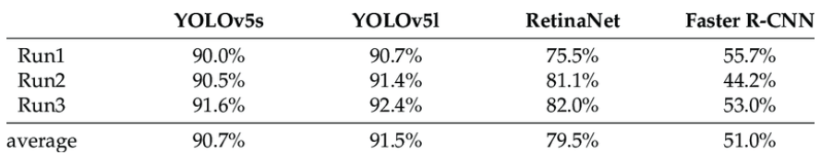

|  |  |  |  |
| --- | --- | --- | --- |
| **Parameters** | **YOLOV5** | **SSD** | **RetinaNet** |
| Backbone | CSPDarknet | VGG16 | ResNet |
| Learning Method | SGD | SGD | SGD |
| Input Resolution | 448*448 | 300*300 | 224*224 |
| Language | C++ | C++ | C++ |
| Platform | DarkNet | Caffe | Caffe |

I will be training YOLOV5,tph-yolov5.

At the end of the project, we will compare performance of all three models.

## Baseline Model

The baseline model for all YOLO, SSD & Retina Net is Convolution Network.

All the three models use state of the art image feature extractors like VGG-16 and Inception.

# **PHASE 2.2**

Submitted as 4 Jupyter Notebook files:

1. YOLO_training
2. RetinaNet training
3. SSD_training
4. Model_Comparisons

# **PHASE 3**

## Summary of Models used:

Model 1: SSD MobileNet V2

* Trained on: MS COCO dataset.
* Object Classes: 90 (Which includes our 12 target classes)  
    
  This model is used for detection as is, without any additional training or transfer learning.  
  Hence, this will give us an idea of how models trained on generic object detection datasets like MS COCO perform on Aerial Images.

Model 2: RetinaNet

* Trained on: VisDrone Dataset of Aerial Images
* Object Classes: 12  
    
  This model was trained on Google Colab and Local System under time and performance constraints.  
  Due to these contraints, the model was trained only for 25 epochs, which is not sufficient.  
  Hence, this will give us an idea of how a self trained model would perform on Aerial Images

Model 3: TPH YOLOv5

* Trained on: VisDrone Dataset of Aerial Images
* Object Classes: 12  
    
  This model was trained professionally on the VisDrone dataset with no constraints.  
  This was model was ranked 5th in the VisDroneDET 2022 challenge.  
  Hence, this will give us an idea of how a State of the Art model would perform on Aerial Images.

## Comparison of mean Average Precision (mAP)

Mean average precision (mAP) is calculated by first gathering a set of predicted object detections and a set of ground truth object annotations.

* For each prediction, IoU is computed with respect to each ground truth box in the image.
* These IoUs are then thresholded to some value (generally between 0.5 and 0.95) and predictions are matched with ground truth boxes using a greedy strategy
* The mean of the AP of all object classes is the mAP.

## Overall mAP:

**Model 1- SSD MobileNet V2**: 0.202

**Model 2- RetinaNet**: 0.2797

**Model 3- TPH YOLOv5:** 0.408

## Class-wise mAP:

|  |  |  |
| --- | --- | --- |
| YOLO | SSD | RetinaNet |
|  |  |  |
|  |  |  |

## Overall Comparison of Models:

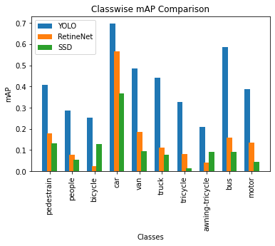

Actual Annotations:

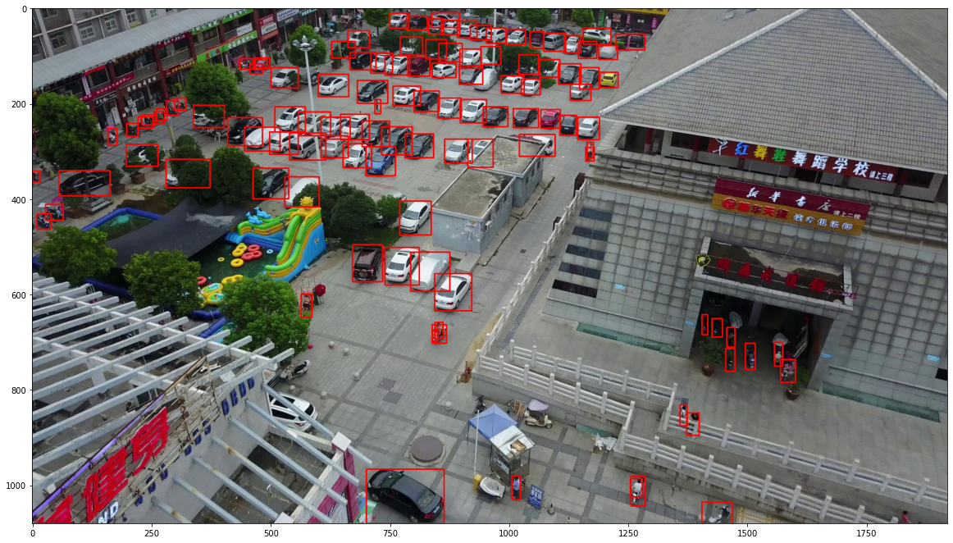

Predictions by RetinaNet:

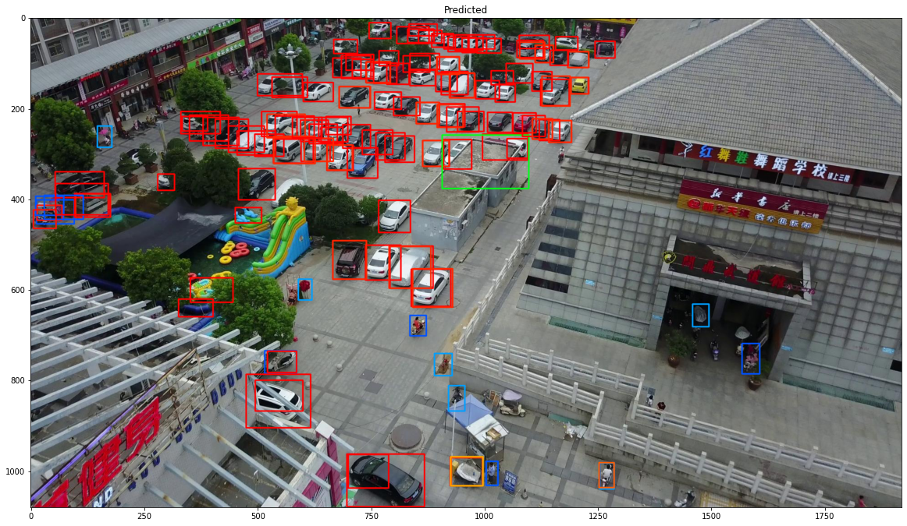

Predictions by SSD: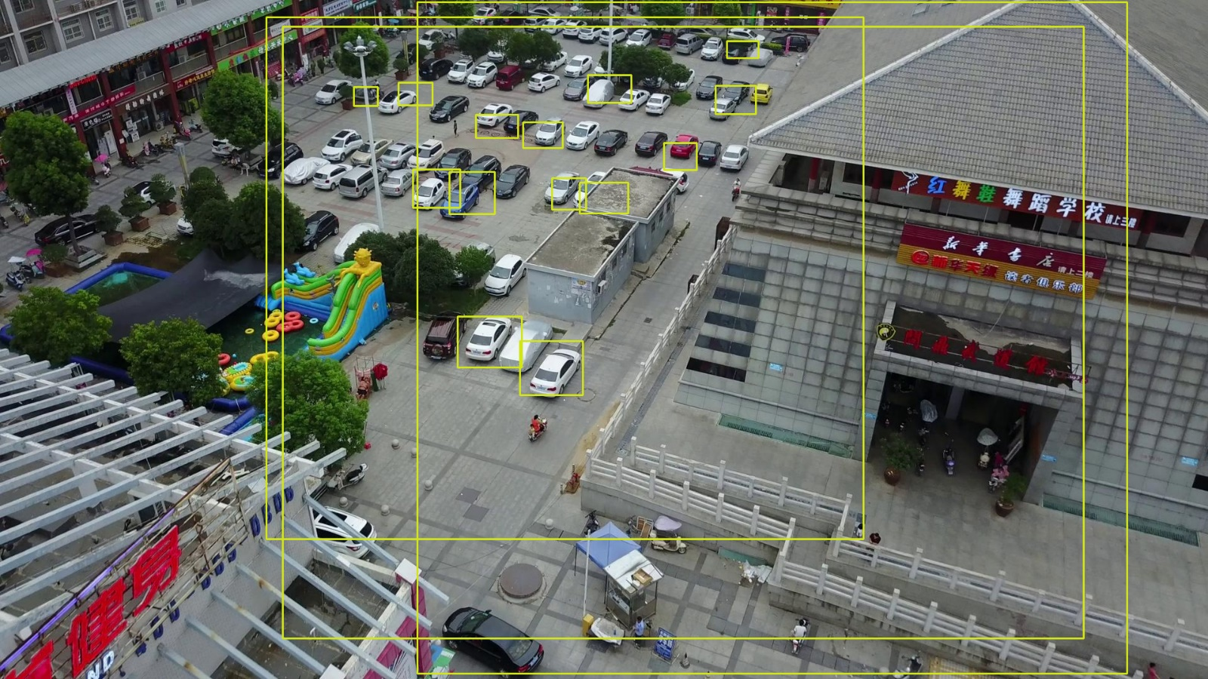

# Conclusion

While all models fail to detect all the objects, we can see that:

1. YOLO model has the maximum mAP score and hence has the best performance
2. RetinaNet model has middling mAP. It needs to trained on much more epochs which is not possible on colab.
3. SSD model has the least mAP. This is apparently becuase proper training of SSD requires 200+ hrs.